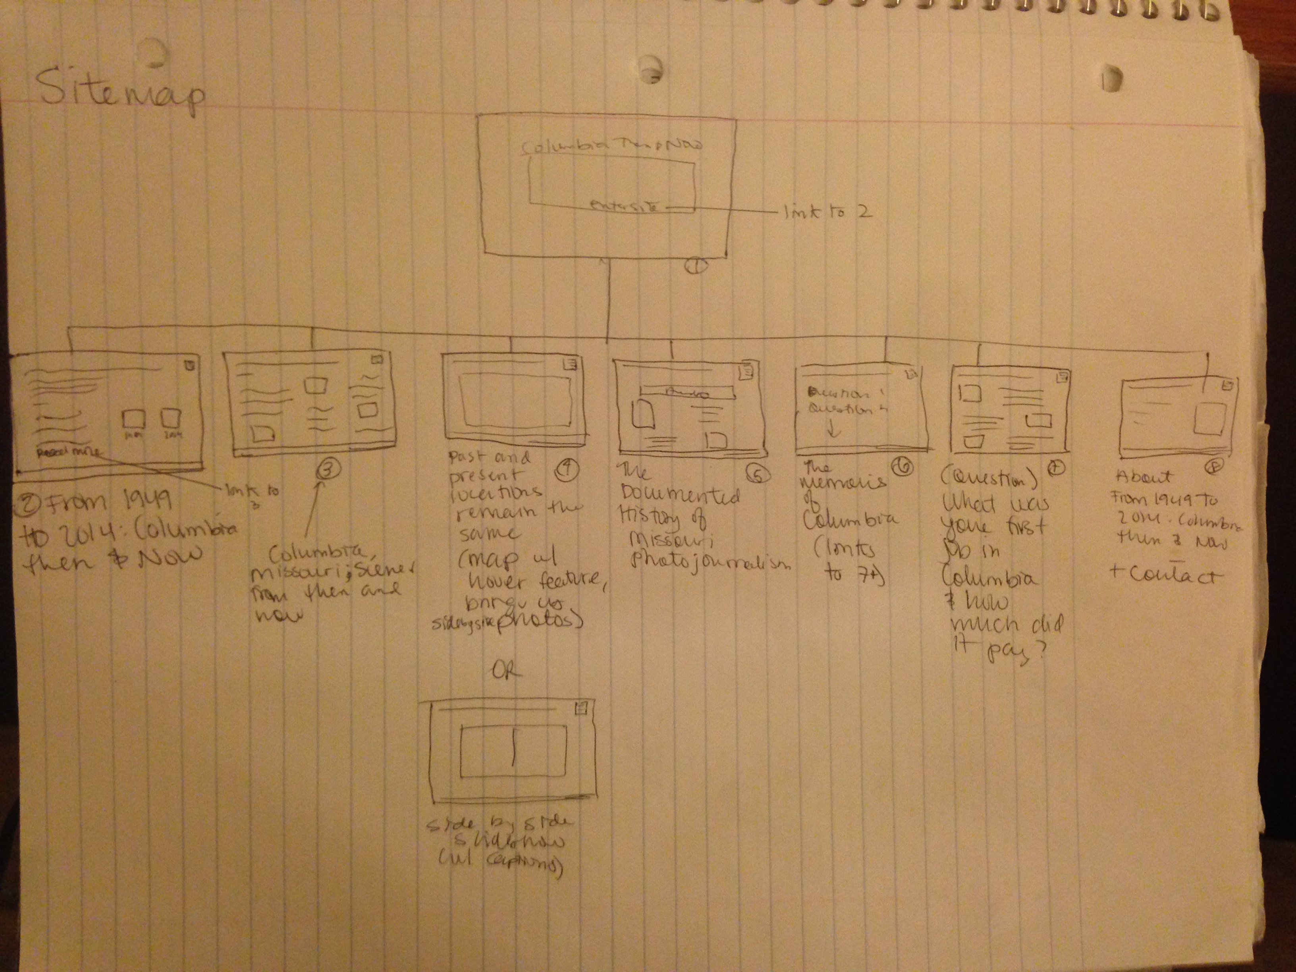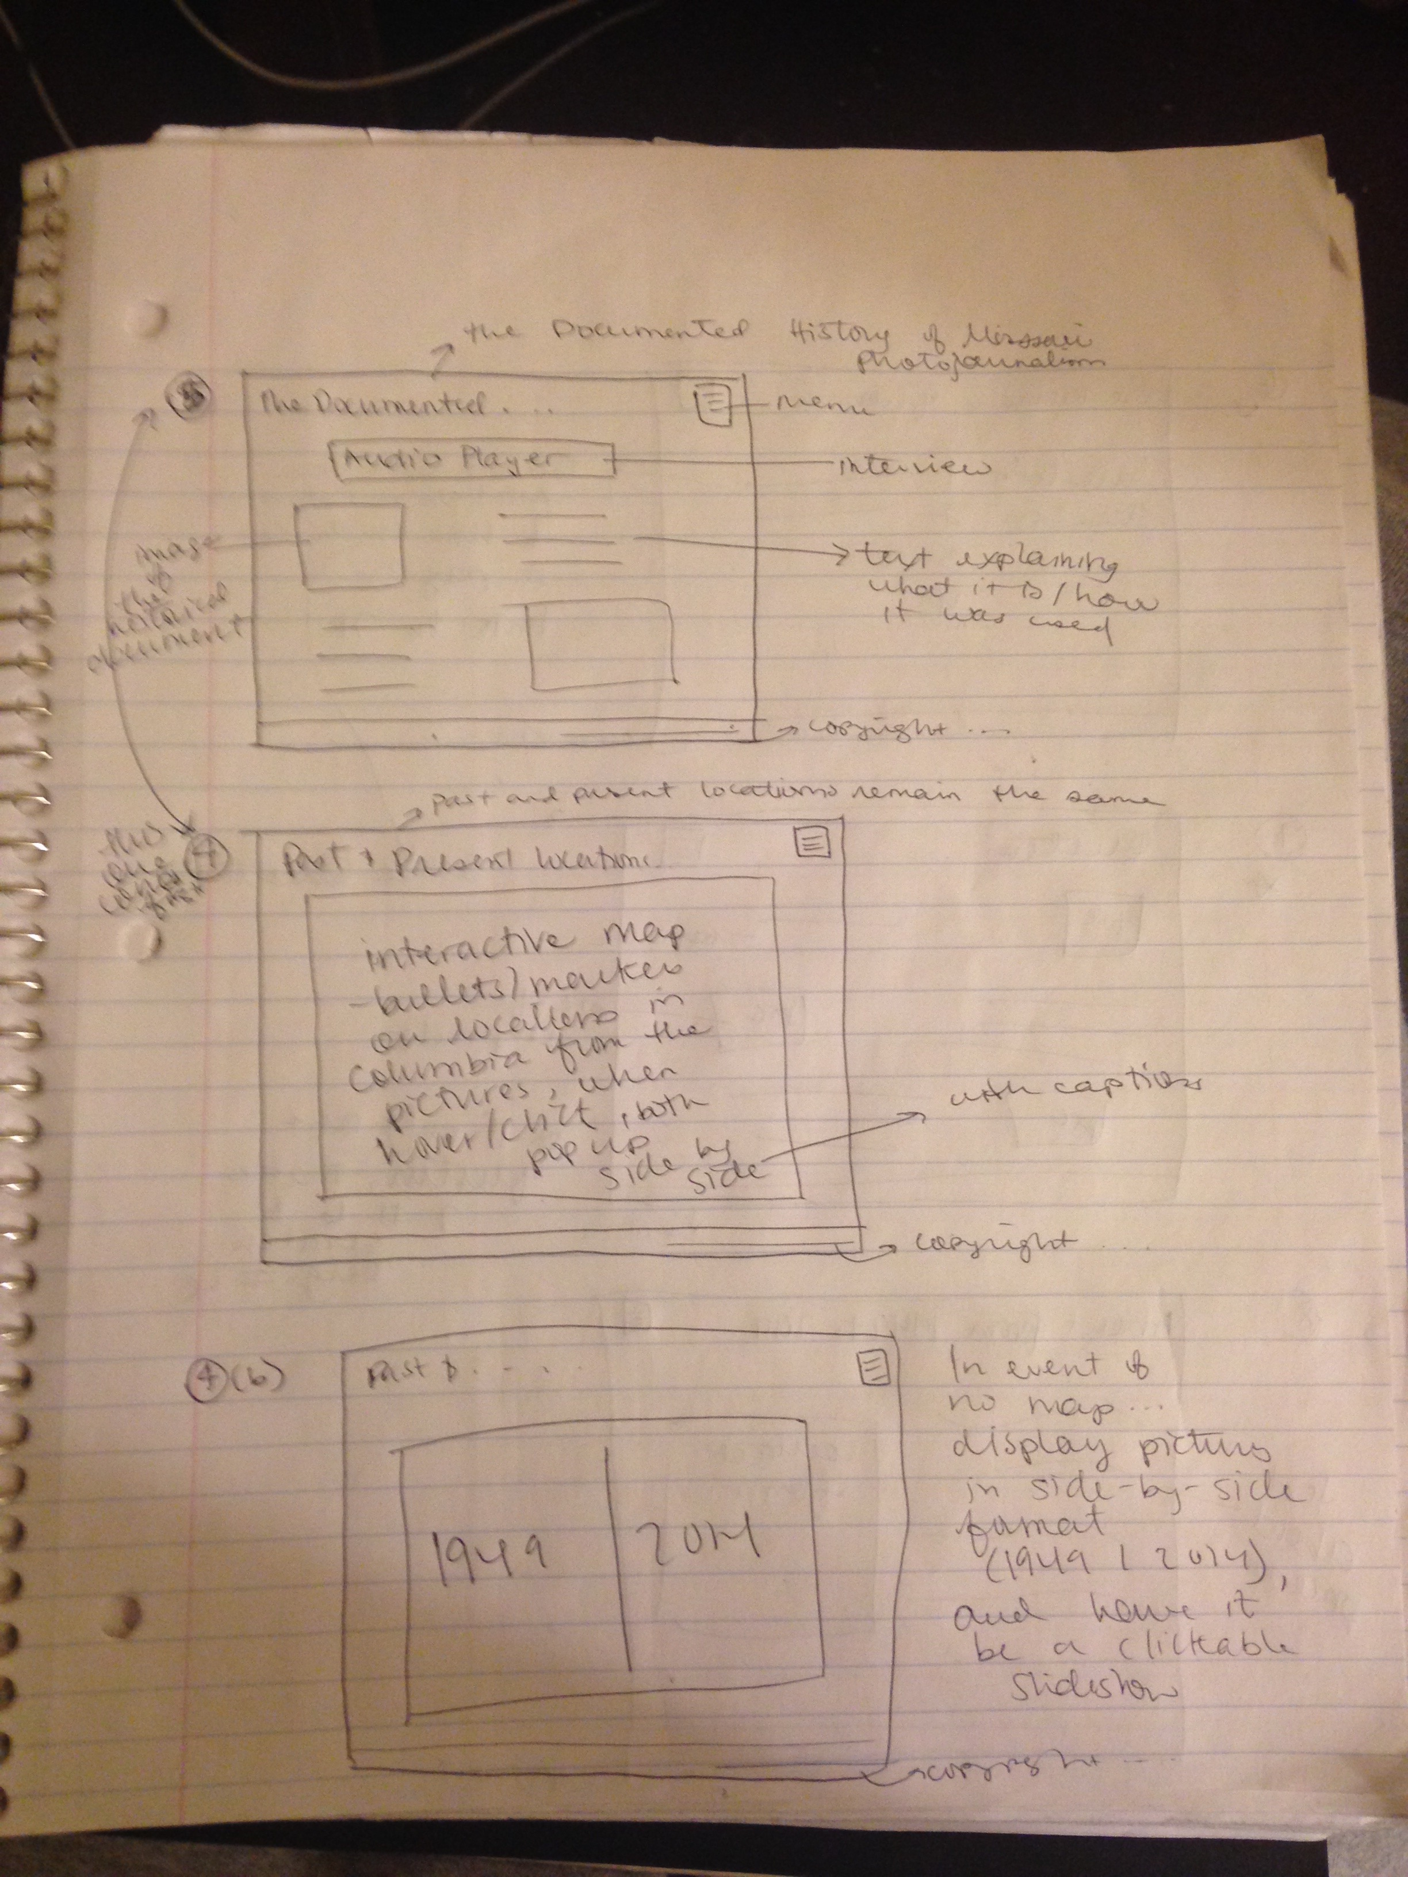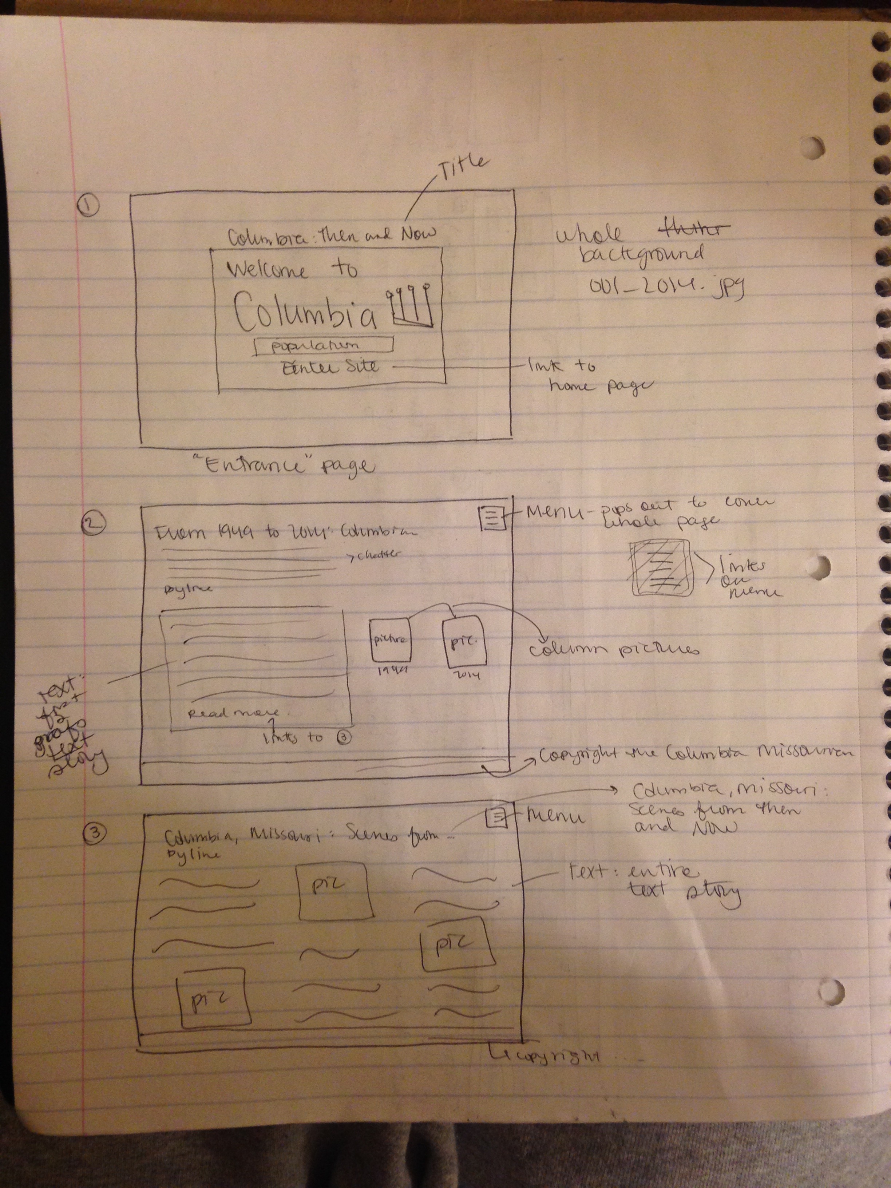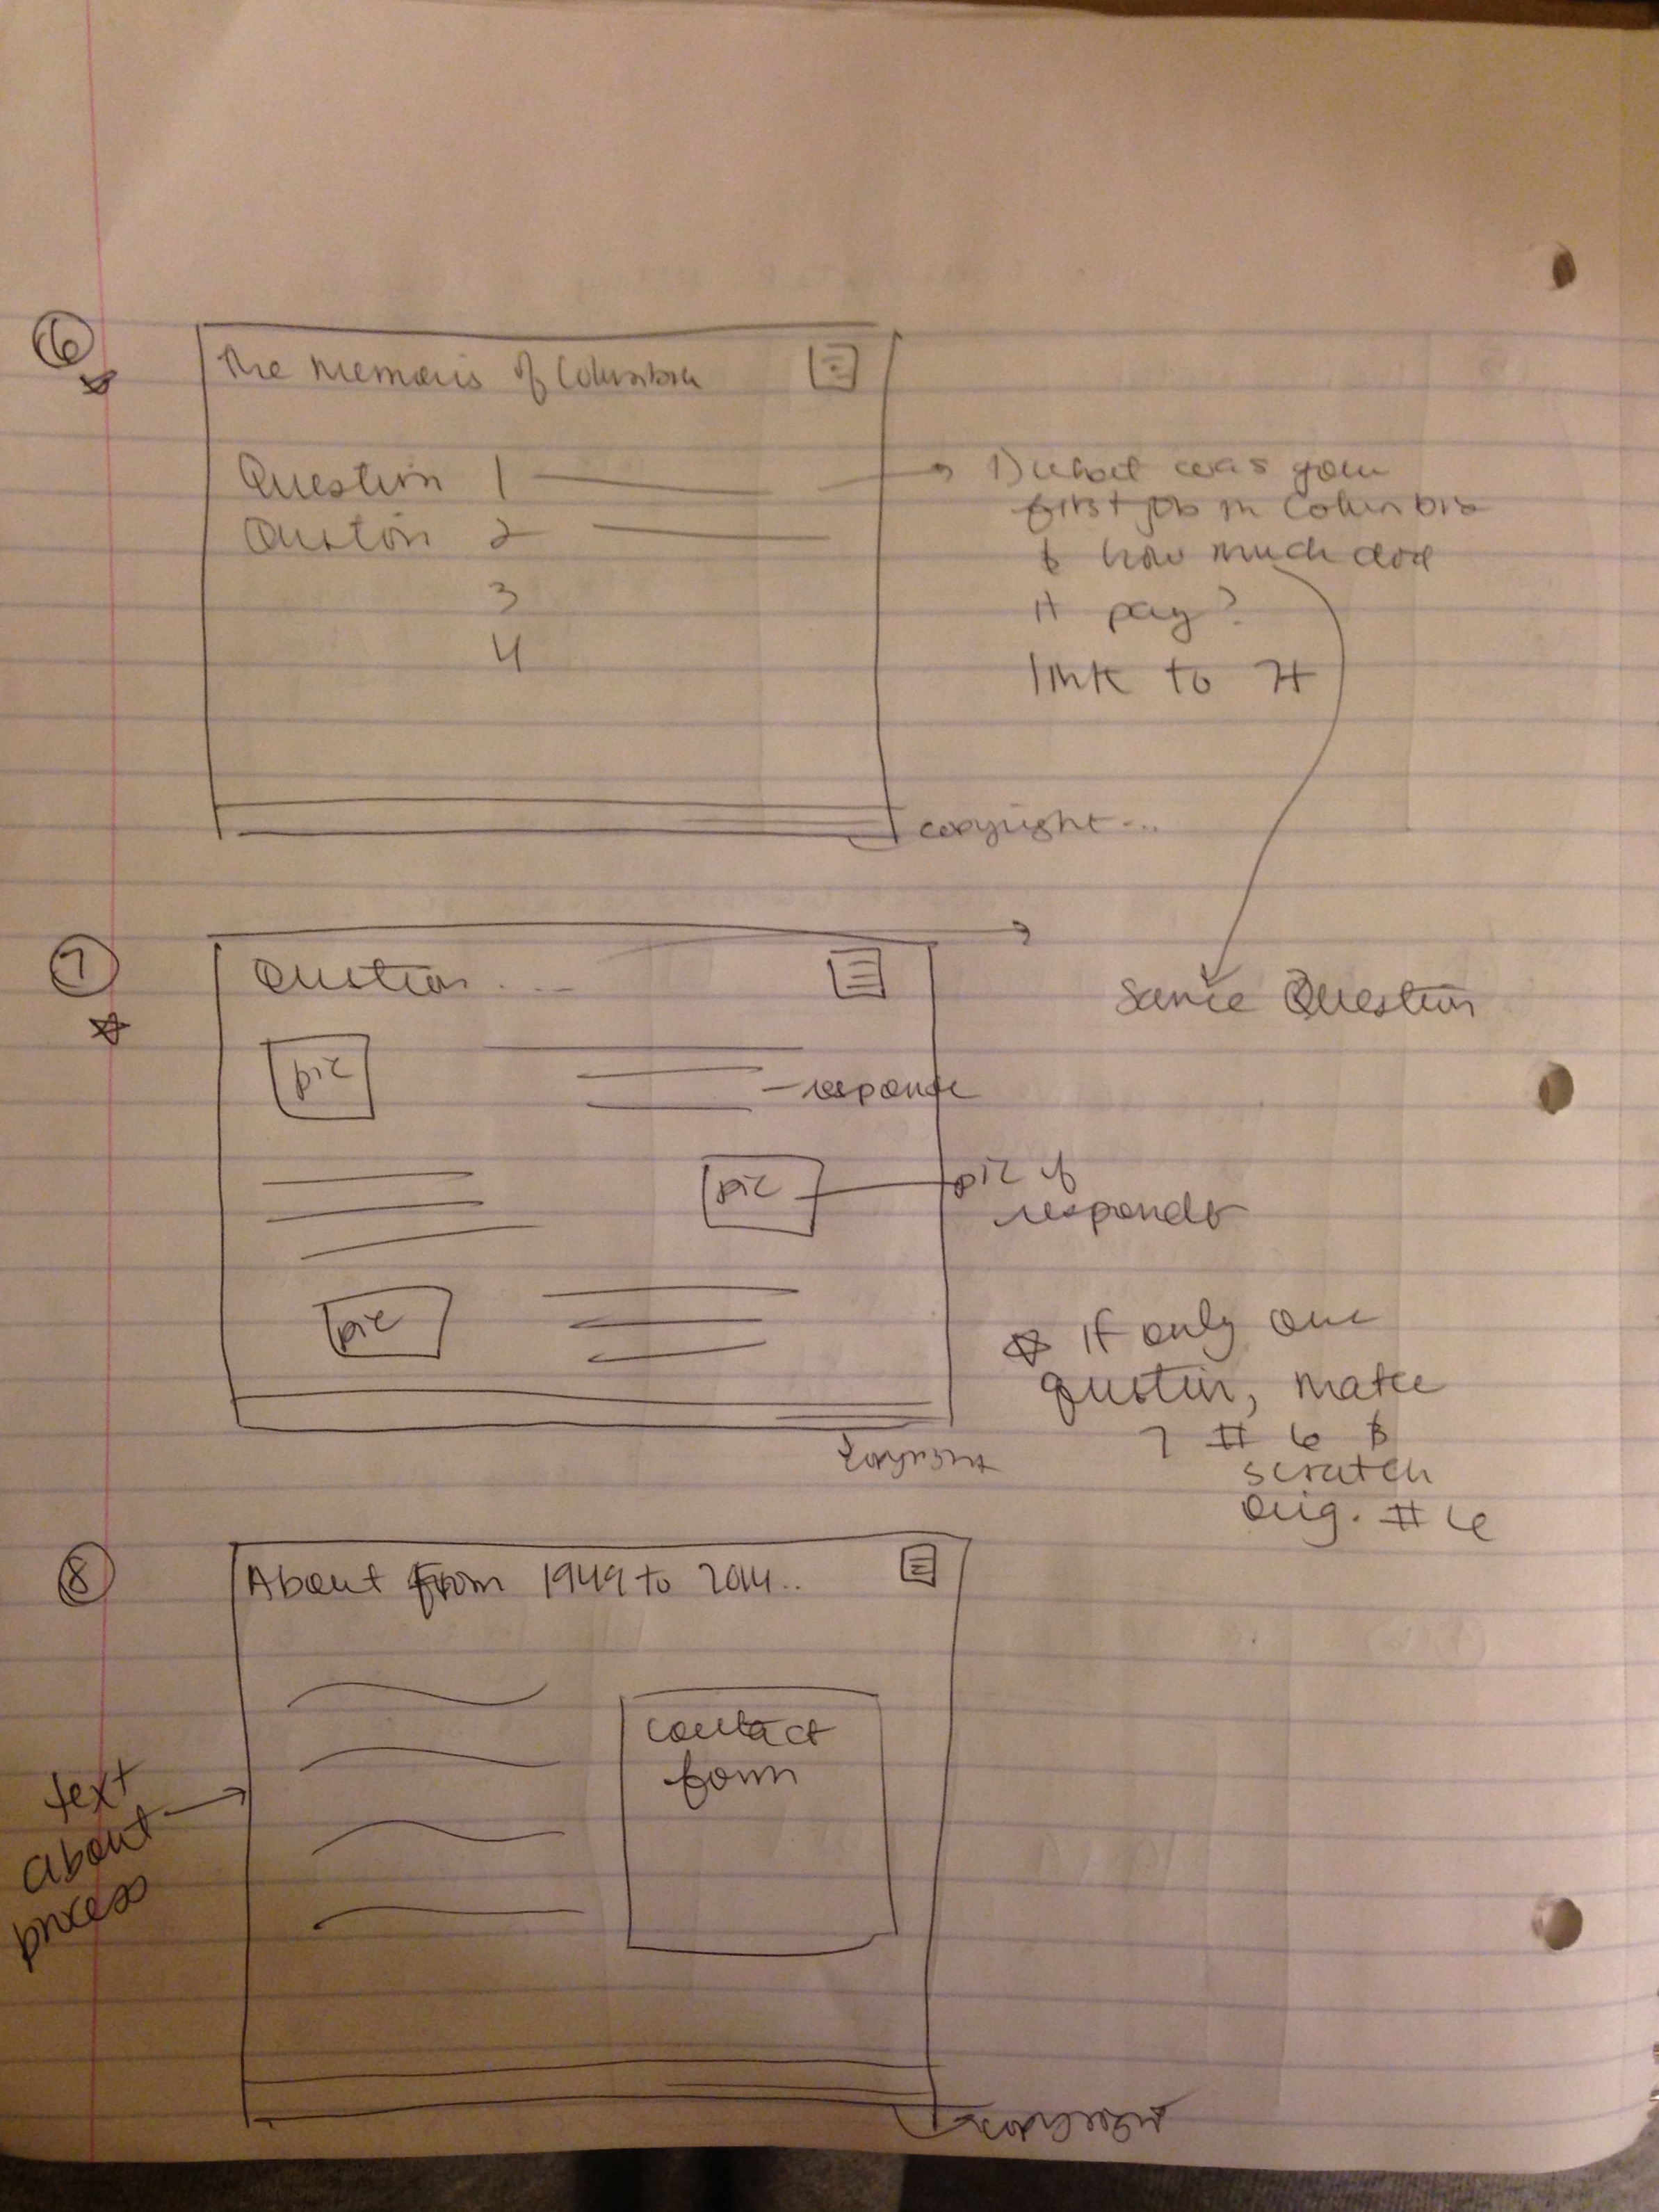

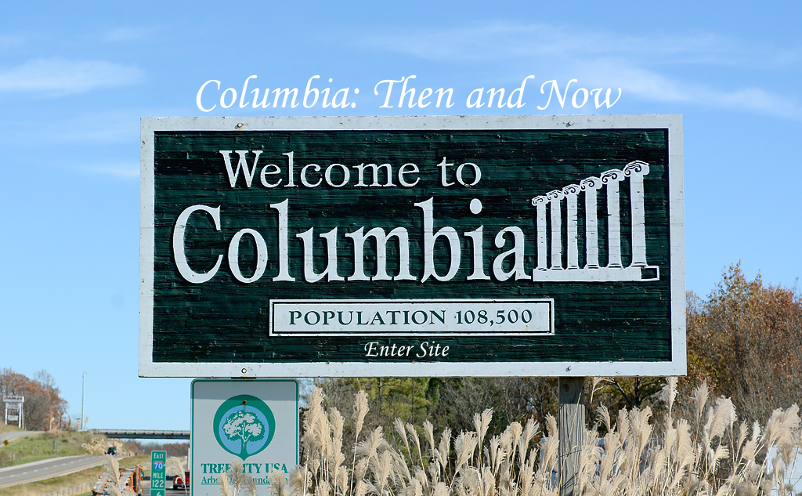

The purpose of this page is to simply give the audience a bit of what the following piece will be. While this is the first page when directed to the URL, this is not the “home” page. It’s like the cover of a book. The design is simple, taking just one of the photographs and placing text on it. The image will be the background (although subdued throughout) for the entire website. The headline is indicated by a different font style and color. It is also placed so that it is clearly readable, but not infringing on the image.

The button to enter the website is indicated by a font that varies from the bulletin sign. But it is still located centrally, so as not to stick out or get lost. (In retrospect, it may need to be bolded or made a bit larger so it stands out a little more.)

The navigation bar isn’t on the home page, but the entrance button takes the audience into the website where a navigation bar will be easily accessible.

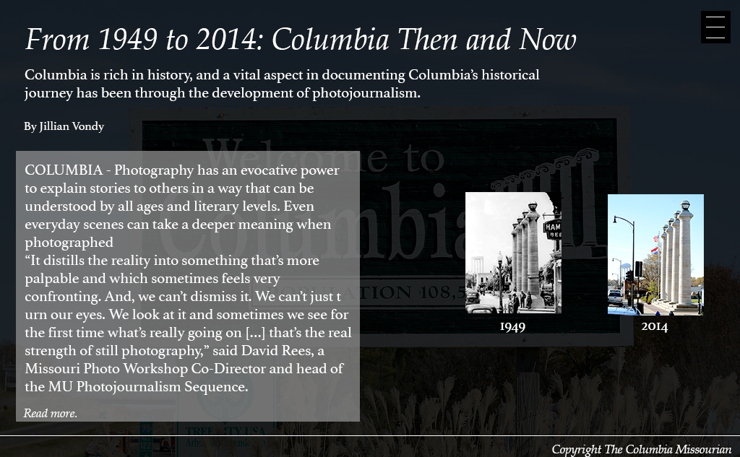

The title page introduces the audience more fully to the subject of the website – the photographic advancement and changes as depicted through images and text. I chose to start the text piece on the main title page because I felt it best explains what the project is about. The images are on the side to supplement and give a visual understanding of how Columbia and photojournalism has evolved.

The headline is a larger, different font so as to distinguish it from the rest of the text. The body text and intro text are the same font of a similar style to the headline. This gives variation without getting too complicated. The background image has an opaque rectangle over it to prevent the background image from overwhelming the text. The text has a grey box around it to make for easier reading. It also distinguishes the body text piece from the headline/chatter/byline.

The menu is in the right hand corner and is clickable. It brings a full-screen menu that links to all of the different pages in the website.